- TE10 Mode Simulation: A WR-90 rectangular waveguide has a = 22.86 mm, b = 10.16 mm and length L = 100 mm. Operate it at f = 10 GHz and excite the dominant TE10 mode in HFSS. Obtain the E-field and H-field distributions, simulated cutoff frequency fc and propagation constant β. Calculate fc (theory) = c/(2a), β = (2πf/c)√[1−(fc/f)²], and the percentage deviation of simulated fc from theoretical fc.

OBJECTIVE:
To develop electromagnetic simulation models for TEM, TE and TM propagation modes in suitable microwave transmission structures.

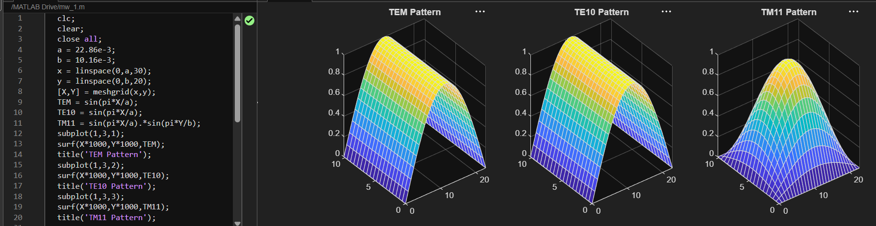
To visualize and analyze the electric-field and magnetic-field distributions associated with different propagation modes
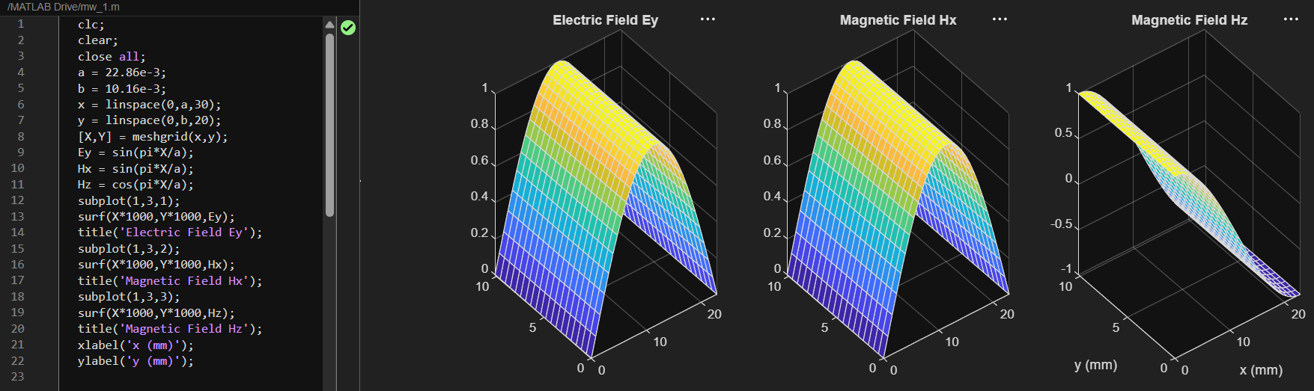
To determine the cutoff frequency, propagation constant and field characteristics of selected TE and TM modes.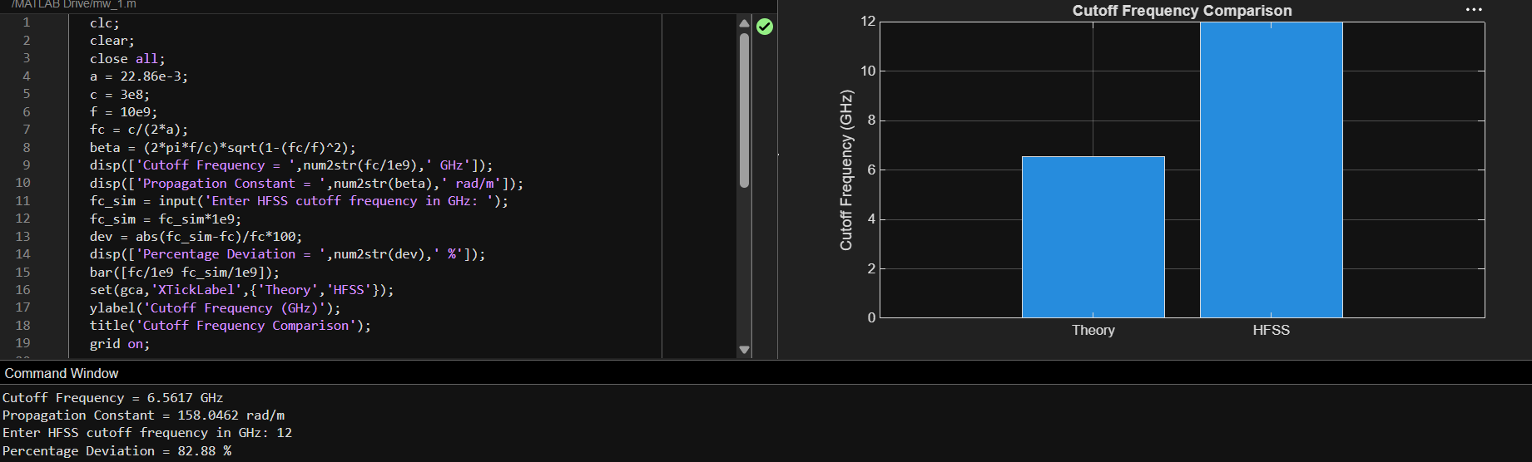
To compare the propagation behavior of different modes and identify their suitability for practical microwave transmission
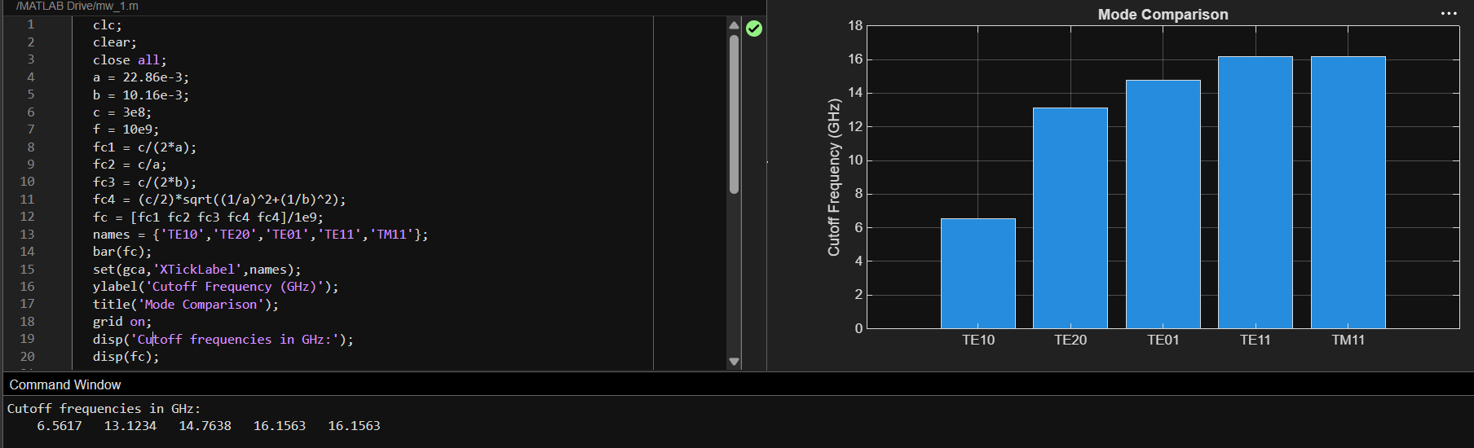
Overall output
